

PANGANI GIRLS’ KCSE PREDICTION
EXAM TEST-2025
312/1
GEOGRAPHY
PAPER 1
TIME: 2¾ HOURS

NAME…………………………………………………………………………………………
SCHOOL………………………………………………. SIGN……………………..
INDEX NO ……………………………………………. DATE…………………….

Kenya Certificate of Secondary Education.

INSTRUCTIONS TO CANDIDATES.
(a)White your name and index number in the spaces provided above.
(b) Sign and write the date of the examination in the spaces provided above.
(c) This paper consists of two sections; A and B.
(d) Answer all the questions in section A and question 6 and any other two questions in section B.
(e) Answer all the questions in English.

SECTION | QUESTIONS | MAXIMUM SCORE | SCORE
A | 1-5 | 25
B | 6 | 25  25  25
 | TOTAL SCORE

SECTION A.
Answer all questions in this section.
- (a) Name two forces responsible for the shape of the earth (2mks)
(b) Mention three effects of the rotation of the earth (3mks)
- (a) Sate two types of igneous rocks (2mks)
(b)Give three characteristics of sedimentary rocks (3mks)
- (a) Differentiate between weathering and mass wasting (2mks)
(b) State three causes of landslides (3mks)
- a) Give three reasons why it is necessary to study the plate tectonic theory. (3 marks)
b) Name two types of plate tectonic boundaries. (2 marks)
- .(a) Name two features that are formed on emerged highland coast (2mks)
(b) State three conditions necessary for the formation of a spit (3mks)

SECTION B
Answer question 6 compulsory and only other two from the remaining questions.
- Study the map of Tambach sheet 90/3 (1:50000) provided and answer the questions that follow.
a) i) In which District is the South Western corner of the map? (1 mark)
ii) Measure the distance of the road C52 from Northing 70 to Northing 75. (2 marks)
b) i) Citing evidence from the map state three social services offered in the area covered by the map. (3 marks)
ii) state three factors that have promoted trade in the area coverd by the map (3 marks)
- i) Describe the drainage of the area covered by the map. (4 marks)
ii) Name three types of vegetation in the area covered by the map. (4 marks)
- i) Using a scale of 1cm represents 20 m, draw a cross section along northing 57 starting from easting 85 to 91. (4 marks)
ii) On your cross section mark and name; (3 marks)
- Road C 51 to Kabarnet
- Gentle slope
- River Kerio
iii) State the intervisibility of the cross section (1 mark)

7.(a) (i) Define continental drift
(ii) Give two significance of plate tectonic boundaries (2mks)
b (i) Apart from tension forces, explain two other process that may cause faulting (4mks)
(ii) With the aid of well-labelled diagrams, describe the formation of Rift valley through tension forces (6mks)
iii) Mention four positive effect of faulting (4mks)
c)You are planning to carry out a field study on the area affected by faulting
- State two objectives for your study
- State three reasons why it is important to have a reconnaissance survey/pre-visit of the area (3mks)
- Give three follow-up activities you are likely to engage in (3mks)

8. a i) Define the term glaciation. (2 marks)
ii) Name three types of glaciers. (3 marks)
b) Describe how the following features found in upland glaciated landscape are formed.
i) U-shaped valley (5 marks)
ii) Pyramidal peak (5 marks)
c) Explain three significances of upland glaciated features to human activities. (6 marks)
d) Suppose you were to carry out a field study of glaciated lowland.
i)State two advantages of using oral interview to collect information during the field study
(2 mks)
ii) Name two features found in glaciated lowland that you are likely to study. (2 marks)

9.(a) (i) Differentiate between watershed and catchment area (2mks)
(ii) Explain three ways by which a river transports its load (6mks)
(b) Study the diagram given below and answer questions that follow
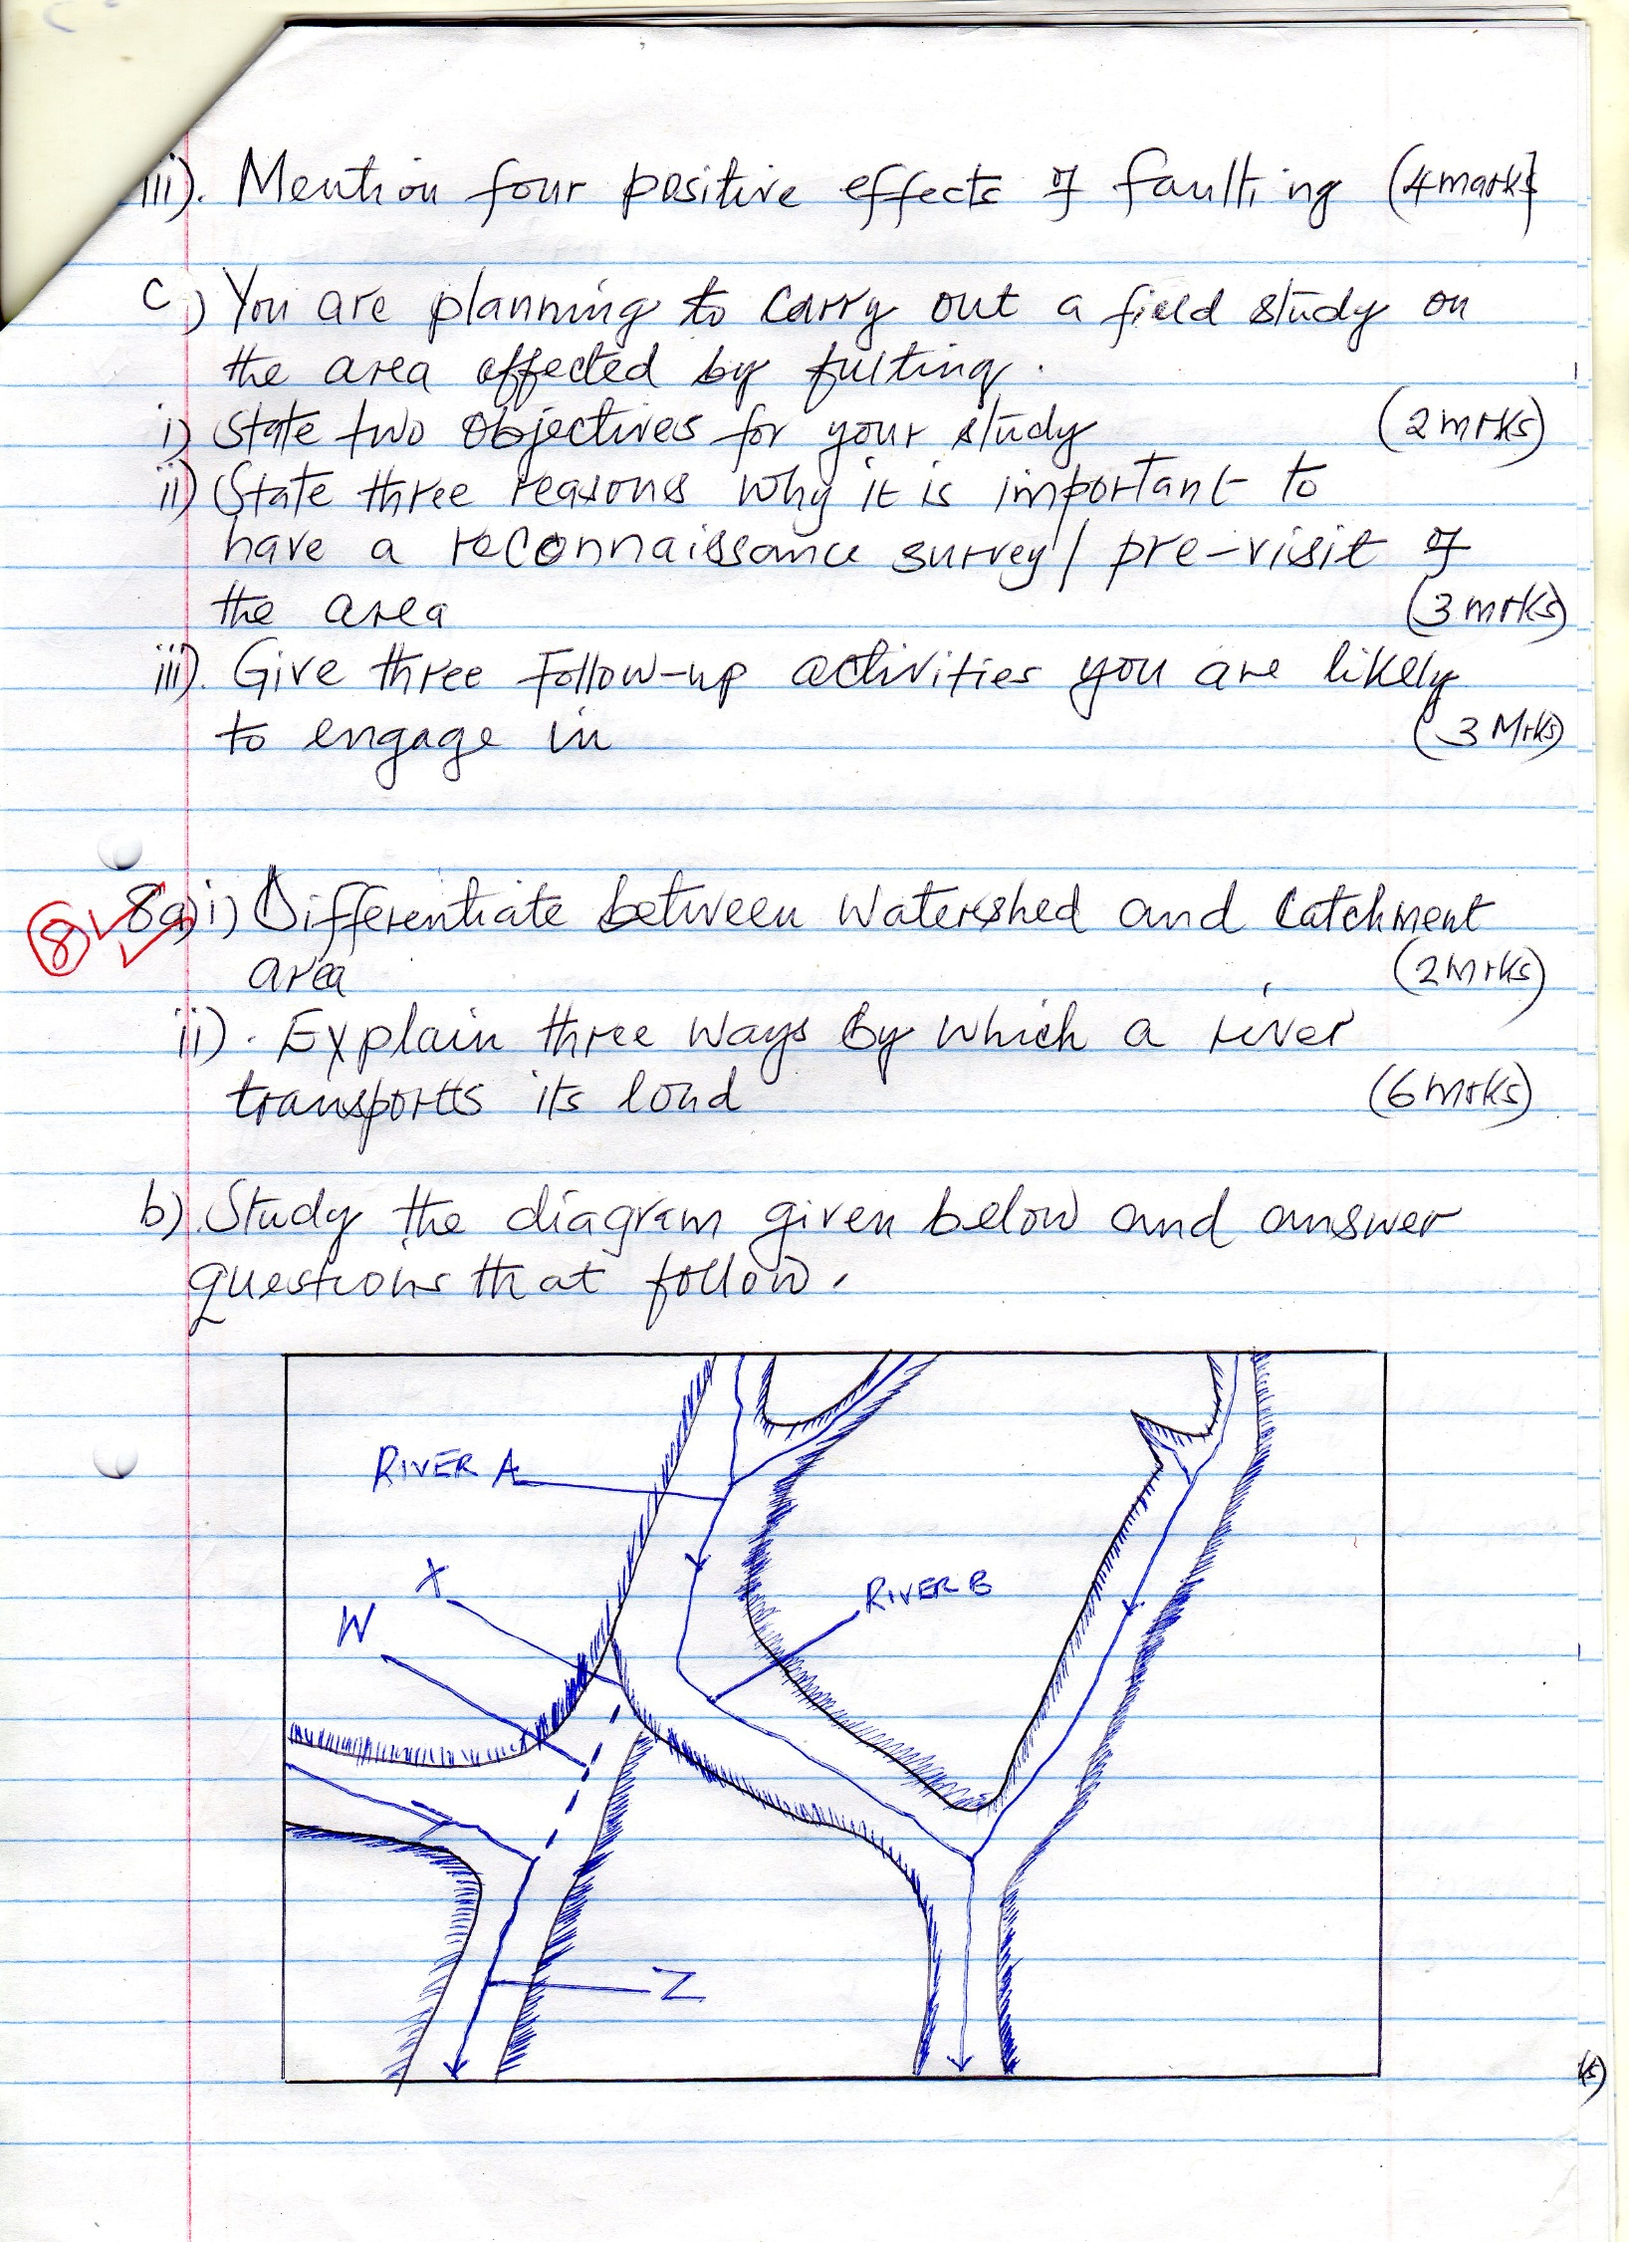
- Name the features marked X, W and Z (3mks)
- Explain the process of river capture (3mks)
c) Give three characteristics of a river in its youthful stage (3mks)
d) Explain four economic importance of a river to human activities (8mks)

10 a, .Define aridity
- With an aid of a well labeled diagram describe how a rock pedestal is formed (5mks)
b ,
- Give two process through which wind erodes the earth surface (2mks)
- Give two wind depositional features found in the desert (2mks)
- explain two ways through which plants causes weathering in arid and semi-arid areas 4mks
c. i. Explain the causes of aridity and desertification (6mks)
ii. State four measures that can control aridity and desertification (4mks)

